DON BOSCO COLLEGE
ANGADIKADAVU, KANNUR – 670 706

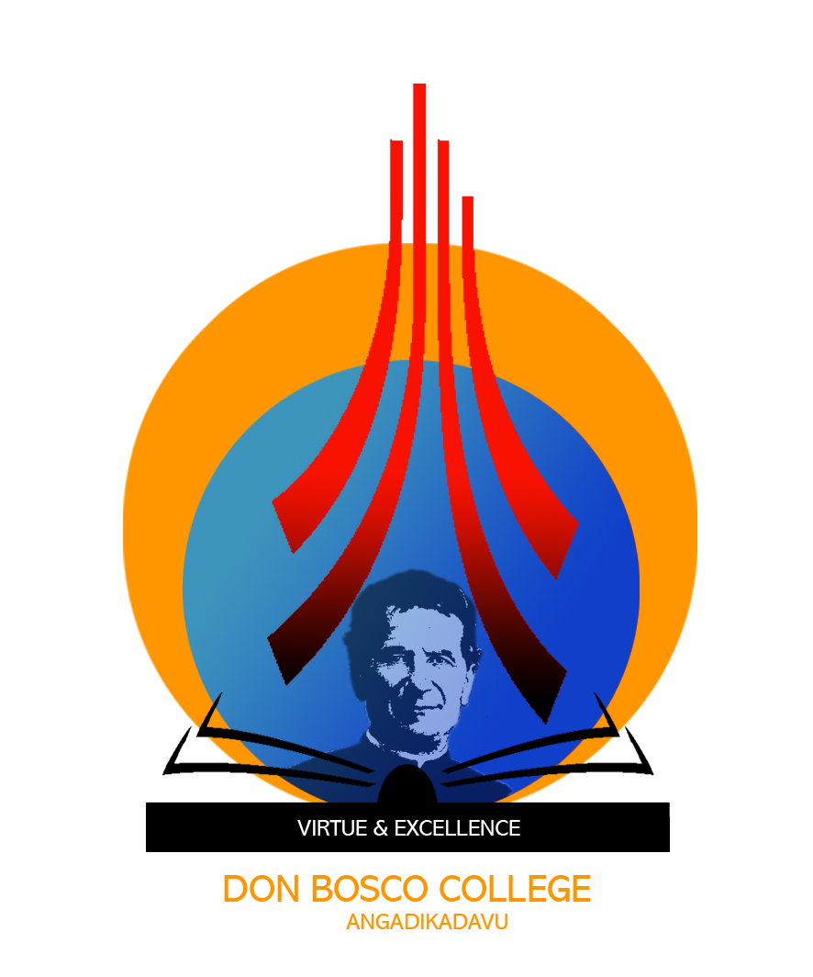

CERTIFICATE

This is to certify that the project entitled HIRE AND BUILD submitted in partial fulfillment of the requirement for the award of M.C.A Degree is a result of bonafide work carried out by SAYOOJ.P (B6GMCA2105) during the year 2019.

Head of the Institution
Don Bosco College
Angadikadavu, Kannur

Internal Guide
Mr.Diljith K Benny
Assistant Professor
DonBosco College Angadikadavu

Examiner 1
Examiner 2

